Gateway Corridor Public Transit Proposal – Twin Cities & Chippewa Valley Steve Terwilliger 1-6-18 draft #3
This proposal supports developing the Gateway Corridor Public Transit System. Observations and suggestions are based on my years of study on transportation, energy and sustainability design.
The Gateway Corridor website from the Minnesota DOT offers eight alternative plans with detailed analysis: http://thegatewaycorridor.com/alternative-analysis/
Alternate #2: The option to me that should be pursued now for these reasons:
- At less than $50 million dollars this project has a realistic chance of going forward. The other options run from 6 to 20 times costlier just to bring the systems into operation.
- Alternate two has the greatest amount of infrastructure and actual operations already in place.
- Putting a system into operation could be accomplished in a very short time.
- This system provides all the basic functionality and service provided by the other options.
- This option offers crucial, expedient establishment of the importance of connected public transit in this corridor. This is an essential step in support of any further development of corridor transit – it is the proof of demand needed to garner support for additional development steps.
Decision Making: It is essential to start from clear, objective definitions of purpose. I list these points:
- Provide public transit between the metropolitan centers of the Chippewa Valley and the greater Minneapolis St. Paul area and population centers in between.
- Provide a public transit option to the private automobile. Almost half of the US population cannot drive, chooses not to drive or should not drive automobiles.
- Reduce traffic congestion and energy use and increase human productivity.
- Provide service between established urban areas that is timely, comfortable and simple to use. Transfers should be held to a minimum and avoided when possible.
- Provide service at a very affordable level so that it can be practically accessed by people of all income levels and frequency of need. Public transit needs to cost significantly less than the cost of driving an automobile for the same journey.
- Provide transit that connects with all other major sources of transit: taxi, car rental, bus, rail, air, bike/bike share, walking, private automobile.
- Provide a transit link that will promote economic, educational, recreational, cultural and social development.
The Minnesota DOT Gateway Study itself established the following Goals:
- Mobility
- Cost effective transit option
- Support economic development
- Protect the natural environment
- Preserve and protect community quality of life
- Improve safety
Cost considerations include:
- Initial capitalization – the cost of infrastructure and equipment needed to start operation.
- Cost of operation – labor, fuel, maintenance, equipment replacement, and business costs.
- Cost of travel to the public – fare prices.
- Ability for the system to be self-financed versus requiring a subsidy.
Cost calculations are difficult to do because of the major changes in population density along the route. My estimates below are for all the alternates and are done using an average for the entire route. First is the 20-year cost per vehicle mile for the capital startup costs, next the operational cost per mile and then an example of an individual’s one-way ticket cost for the 100-mile length of the route:
- Route alt #2: $0.60 capital + $3 operating = $3.60/mi. or $15 trip. (add I-94 bus lane + parking)
- Route alt #3: $4.05 capital + $3 operating = $7.05/mi. or $35 trip. (BRT, STP-Wdbry, bus lane-WI)
- Route alt #4: $7.95 capital + $3 operating = $7.77/mi. or $39 trip. (BRT, STP-Hudson, bus lane-WI)
- Route alt #5: $15.86 capital + $3 operating = $12.52/mi. or $63 trip. (LRT, STP-Wdbry, bus lane-WI)
- Route alt #6: $20.73 capital + $3 operating = $15.44/mi. or $77 trip. (LRT, STP-Wdbry, bus lane-WI)
- Route alt #7: $19.89 capital + $3 operating = $14.93/mi. or $75 trip. (Commuter Rail, Minn. – EC)
- Route alt #8: $9.51 capital + $3 operating = $8.71/mi. or $44 trip. (BRT, STP-Hudson, express-EC)
(9,000 passengers/day, average 25 mi trip, average 20-person occupancy per vehicle trip, 1,642,500,000 passenger miles in 20 years)
(Automobile US average full cost: $1.10/mi. / 1.5 average occupancy = $0.73/mi. or $73 for same trip)
(Auto US average out-of-pocket cost: $0.75/mi / 1.5 average occupancy = $0.50/mi or $50 for same trip [$8-12+ gas only])

Additions/Modifications to Alternate #2: please see the following at the end of this document:
- Maps
- Scheduling and stop protocol
- Community transport links
- Station design
- Payment methods
- Vehicle design
- Rider conduct code
- Business Coordination
Conclusion:
I believe pursuing development of the Gateway Corridor is of great current importance. My suggestions support a revenue neutral, entirely fare supported option that realizes all the stated project goals. Additions to the alternate #2 route I suggest would significantly increase the benefits of the project goals, significantly increase its attractiveness to potential users and greatly add to its likelihood for success. For this project to be successful it must be complete from the start. Piece-meal development will not attract the essential proof of multi-purpose user participation.
A critical element in the project plan is affordability for users, including members of governments and institutions. My family, friends and I would regularly use alternate #2. Wide public acceptance will depend on such a system not imposing any public subsidy burdens. This project is an ideal candidate for economic development through revolving development loan funds like those just proposed for Wisconsin.
In light of major recent cuts to UW system funding, I see this transit system providing a vital linking of the corridor universities and colleges for practical student/staff mobility - helping to create shared institutional strength.
The suggested plan makes full use of existing transit investments, existing, proven technologies and is fully flexible to respond to developing demographic needs.
Jeff Speck in his important book Walkable Cities emphasizes the following necessities in public transit:
- Urbanity – goes right to where people want to go and is walkable at both ends [connected at both ends]
- Clarity – simple and familiar (people hate figuring out routes and schedules)
- Frequency – no more than 10-minute wait (don’t waste people’s time) [several times a day for the east/Wisconsin corridor]
- Pleasure – make people happy – the trip is pleasant and safe.
I would add to this list affordability – it must cost no more than using a private automobile and preferably significantly less.

Design Appendices
- Route maps:
Alternate #2 from the Gateway Corridor Study
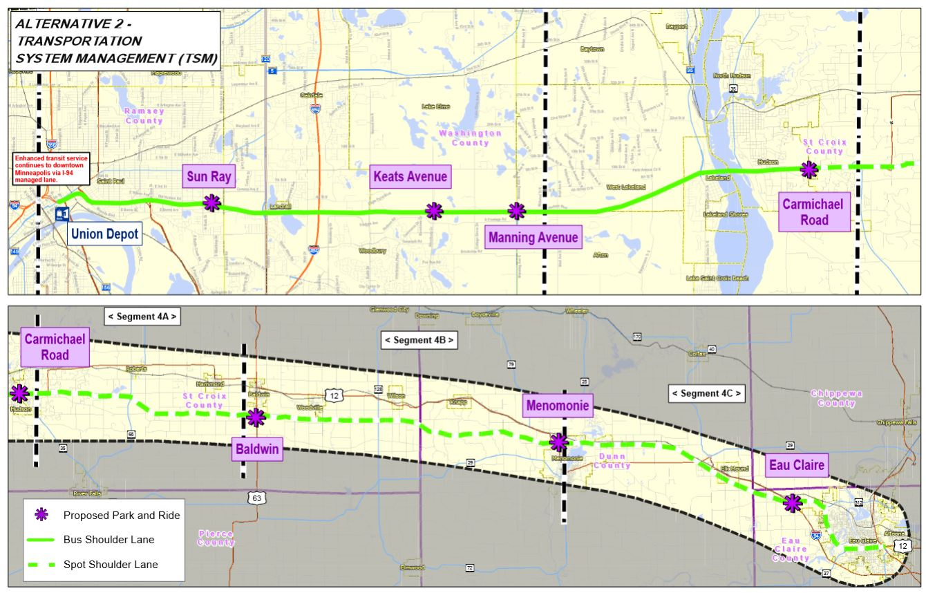
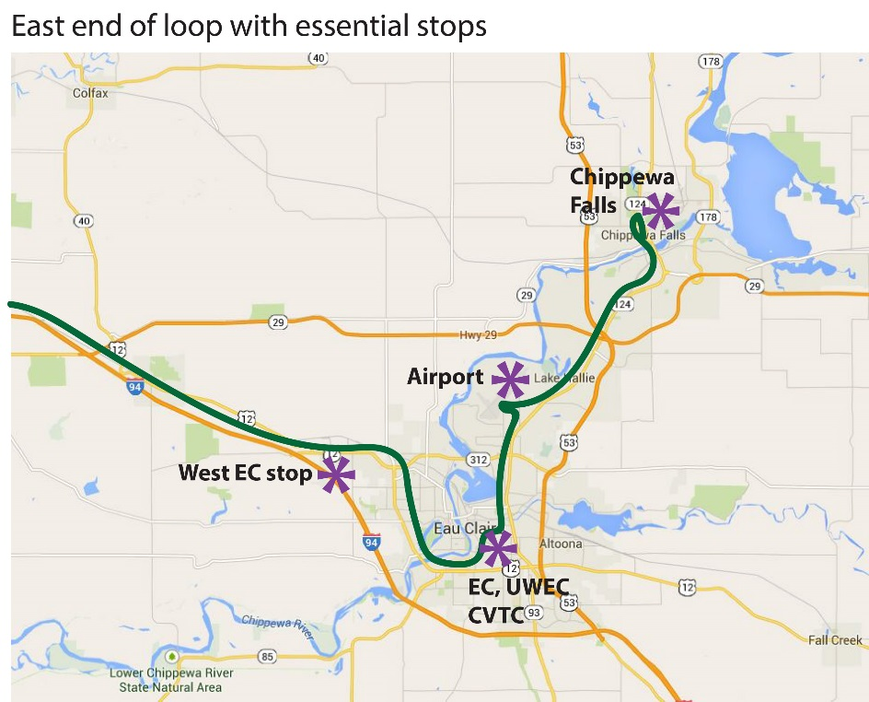
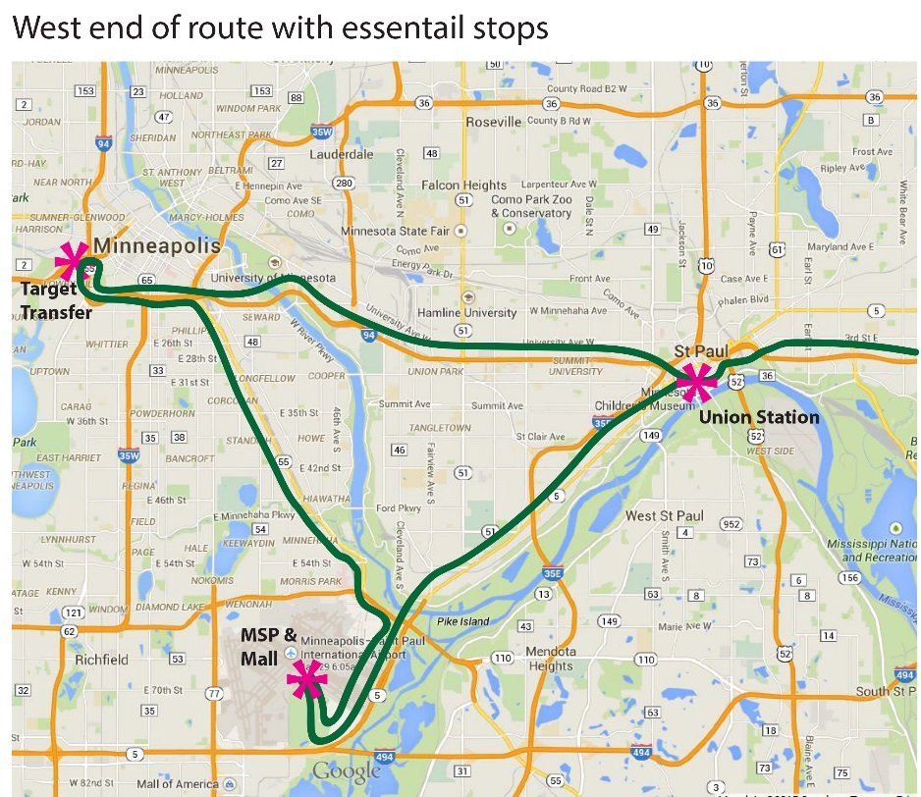

- Scheduling and stop protocol:
- Route is a closed loop with no actual “center.”
- Buses run in BRT (bus rapid transit) style – stop, get-off, get-on, and take off.
- Route time from West EC to MSP Airport = 2hrs or less. West loop = 40 min., east loop = 50 min.
- Several complete loops a day. Times selected to best serve user purposes and connections. For example, from CF east point: 5am, 7am, 11am, 3pm, 5pm, 9pm, 12am. Times added when demand increases. Weekends might vary. Size of bus and schedule tailored to demand history.

- Community Transit Links:
- Establishing effective local public transit first is essential for success of system. Regional transit systems will not work without it. Please see my suggestion in the companion document: On Demand Shared Urban Shuttle. This local transit system is ideally suited to provide the needed local connections to a regional corridor public transit system. It runs quickly, on demand, at low cost, from any point to any point locally, 24/7. It is also revenue neutral.
- Existing public transit systems will need to include stops coordinated with the corridor stops.
- Individuals can park a private auto at any of the Wisconsin stops (park and ride).
- People can be dropped off at any of the stops or walk/bike up.

- Station Design:
- Existing structures are used, upgraded or new ones built as needed. They offer weather enclosure and heat/air conditioning as needed when riders are waiting (waits are short).
- Stations are pull-up/take-off designed in the BRT style. A stop might take 30 seconds or less.
- Station to bus doors are close proximity to and exact alignment with bus doors. Buses pull under roofs. Entry/exit is very easy and fully ADA compliant. Weather exposure is minimal.
- I-94 stops are located at the bottom or top of off ramps with adjoining parking lots. Buses do not turn onto secondary roadways.
- Stations have monitors showing locations of buses on the loop and expected arrival times. They also have CCTV for safety and security.

- Payment methods:
- Bus system is fully electronically connected. Seats can be reserved ahead by smart phone, tablet, or pc.
- Walk-in riders can pay by cell phone, transit card, credit card or cash at a simple terminal in the station.
- Users can buy prepaid transit cards at any station and recharge them anywhere. Smart phones will be the easiest, most secure way of paying.
- There are no payment or money transactions on the buses – essential for time efficiency.
- Reduced rates for: Children, families with children, students, monthly fares, those with income subsidies.

- Bus Design:
- Existing buses can be used initially within the mix of vehicles.
- Multiple bus sizes are used to enable scaling capacity to demand. Size would range from minivan to 45-60 passenger. Historic and real-time demand would determine capacity and number of buses to use.
- New buses are designed to have individual seats, paired seats and quad seating. Seats are assigned.
- Interiors are comfortable, with fold down or quad seating tables.
- Buses are wired for high-speed internet. Ride time can be spent working, resting, reading, playing games, conversing, or watching entertainment.
- Buses running the full-length loop are restroom equipped.
- Luggage and packages are accommodated in a specified space. There are bicycle and ski areas possibly with small extra charge – also for oversized or large quantity of bags or packages.
- Buses are carefully cleaned and maintained and are free of advertising.
- Regional transit vehicles are ideally suited to evolve to EV power and run entirely on renewable energy.

- Rider conduct code:
- Riders are required to be familiar with the posted conduct code. Significant or repeated infractions will remove a user’s riding privileges.
- I have a detailed code in another document, but briefly, infractions include: aggressive, unpleasant or loud behavior, intoxicated behavior or consumption of intoxicants, display of offensive materials or offensive conduct, weapons of any type, audible electronics, proselytizing or promoting.
- Individual riders must take individual seats. Pairs of riders use dual seats and groups of 3 or 4 traveling together, including families, use quad seating.
- Fully positive rider experience is a crucial aspect for success of the system. Polls show the number one reason why people do not want to ride a bus is the unpleasantness of the experience and the image of being a bus rider.

- Business Coordination:
- The above plan can be run by a private Chippewa Valley or regionally based company. Other models might be considered. Coordination/integration with existing Minnesota/Minneapolis-St. Paul transit would be necessary.
- Existing transit businesses could expand to provide this corridor transit. They have a base of structure, experience and personnel.
- It is critical to follow the ABC progression when planning to establish an effective public transit system. Step “A” is to have in place a fully functioning, effective and widely used local transit system (my document On-Demand Shared Urban Shuttle covers an example). Without step “A” there can be no hope for success of step “B,” in this case a public regional transit corridor. In such a case – with no “A” support, businesses and the public will, from their perspective, wisely, not be interested in investing in such a step “B” venture. National level public transit is step “C” and at this time is essentially being covered by air transit – other options could be developed once the local and then the regional are in place.
- When all regional transit systems exist across the country, they would all be interconnect and in effect establish a national transit system. Longer range BRT type vehicles could ply routes across multiple regional systems without passengers transferring and be used as a national transit system.

